**Assignment 2**

|  |  |  |  |
| --- | --- | --- | --- |
| Name | Section | BN | Student code |
| Abdelrahman Mohamed Salem Hassan | 1 | 38 | 9202794 |
| Ahmed Fawzy Mohamed Ibrahim | 1 | 8 | 9202153 |

**Table of Contents**

Table of Contents

**Part1 Solution2**

**Derivation of theoretical probability of error6**

**Simulation of the system (graphs)14**

Output of the binary source14

Pulse shape output15

Channel output16

Matched filter output17

Decoders output20

**Is the BER an increasing or a decreasing function of E/No?25**

**Which case has the lowest BER? Why?25**

**total code26**

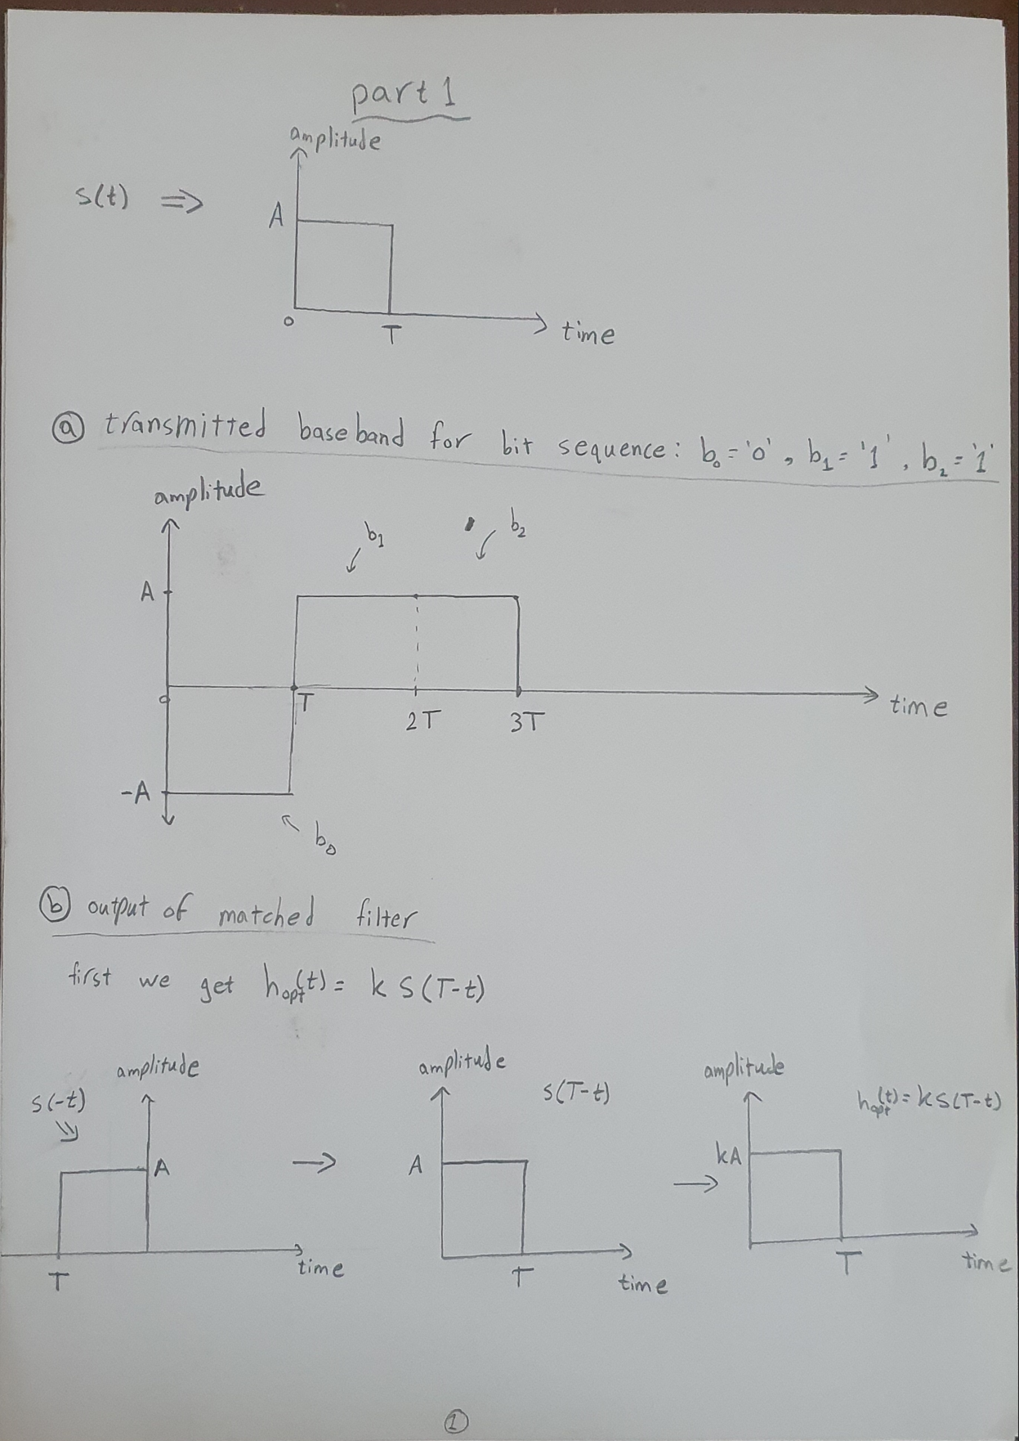**Part1 Solution**

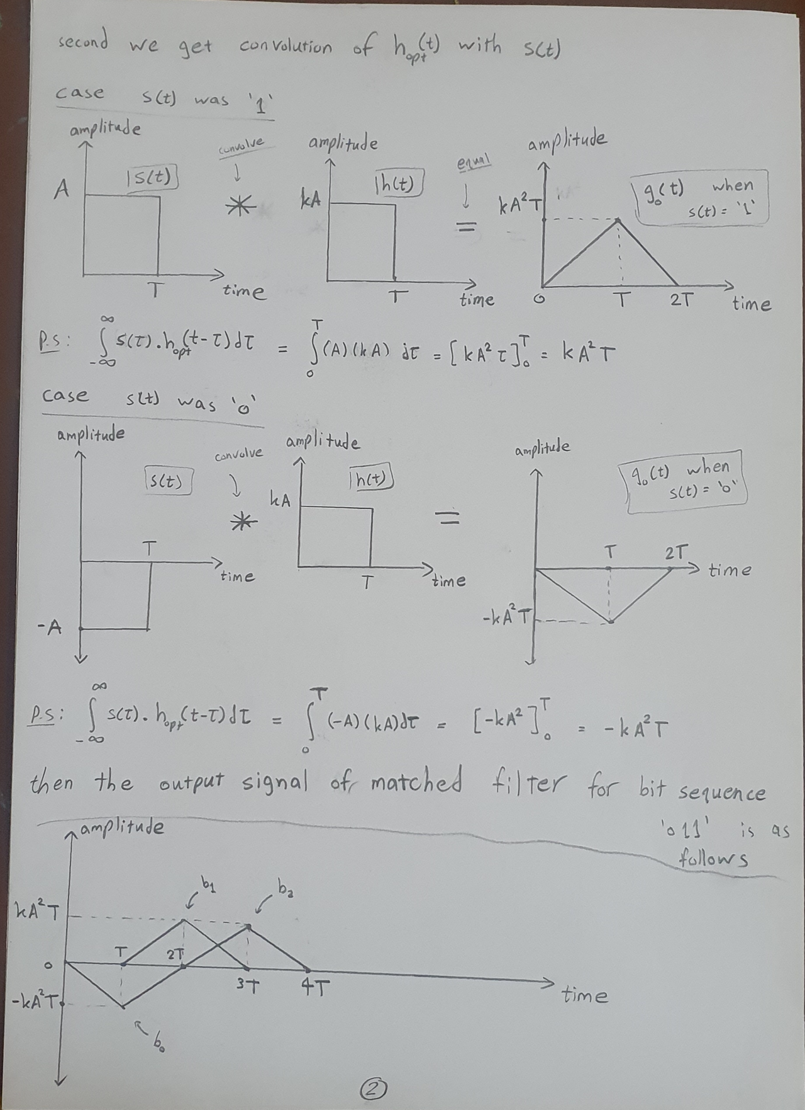

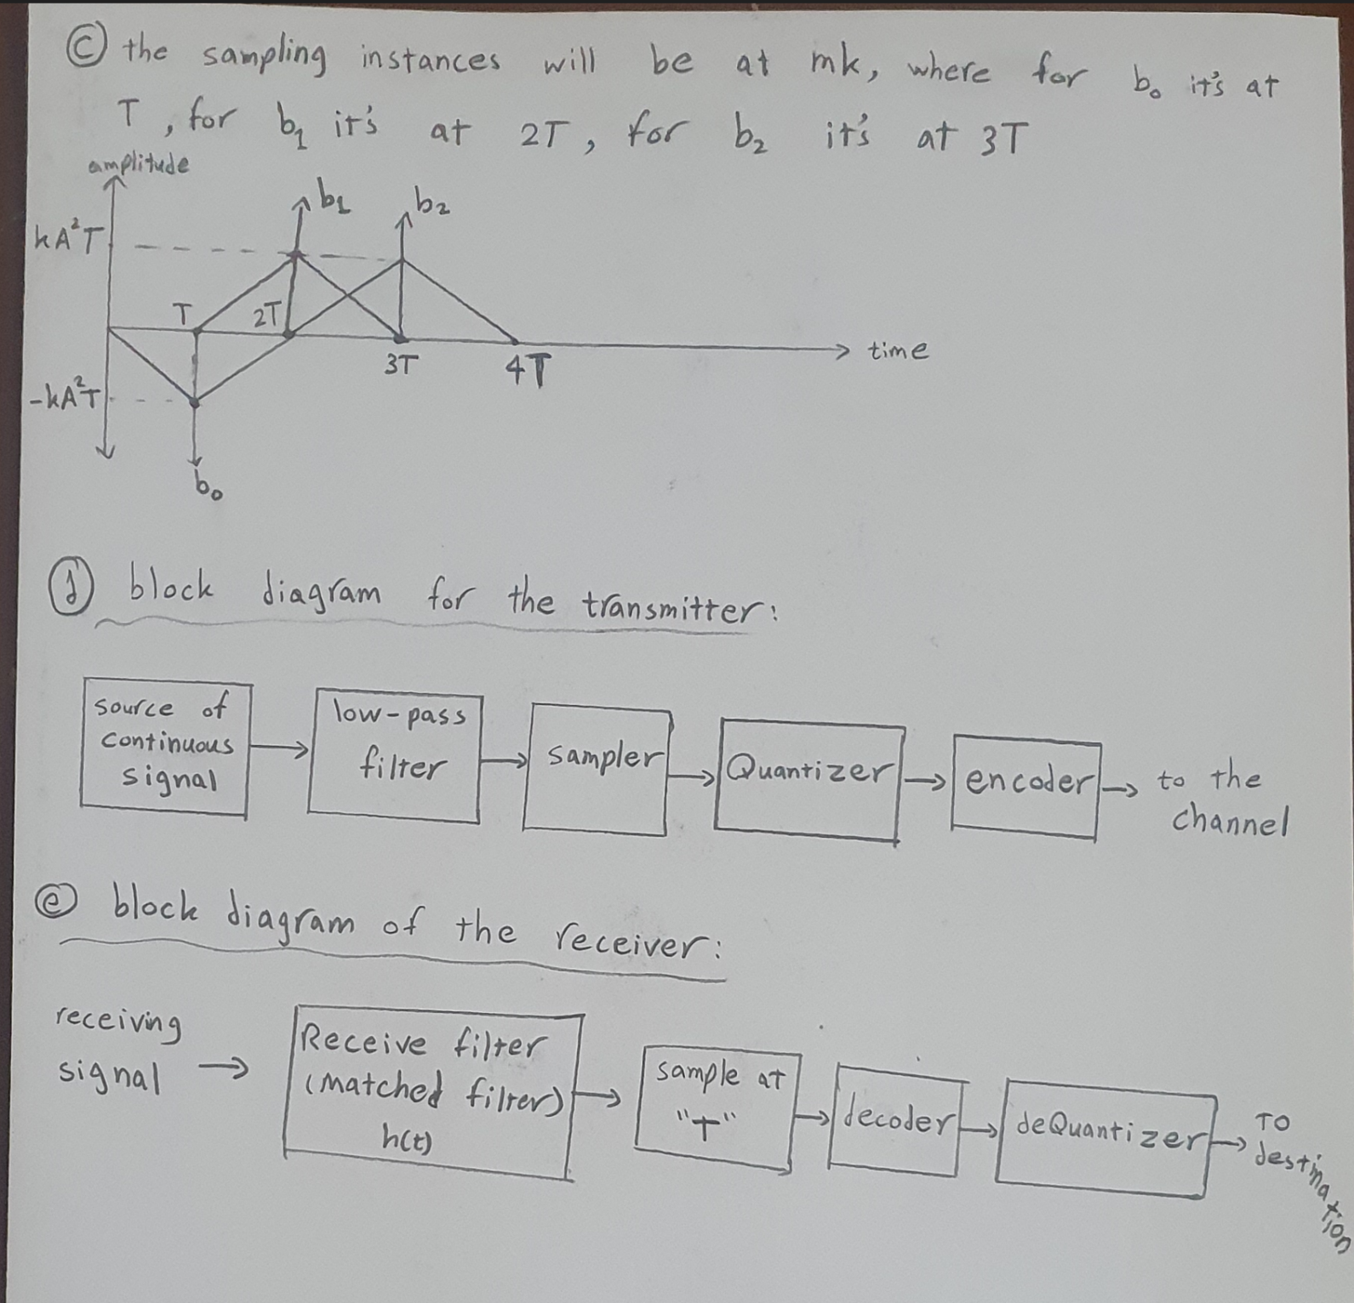

**Part2 Solution**

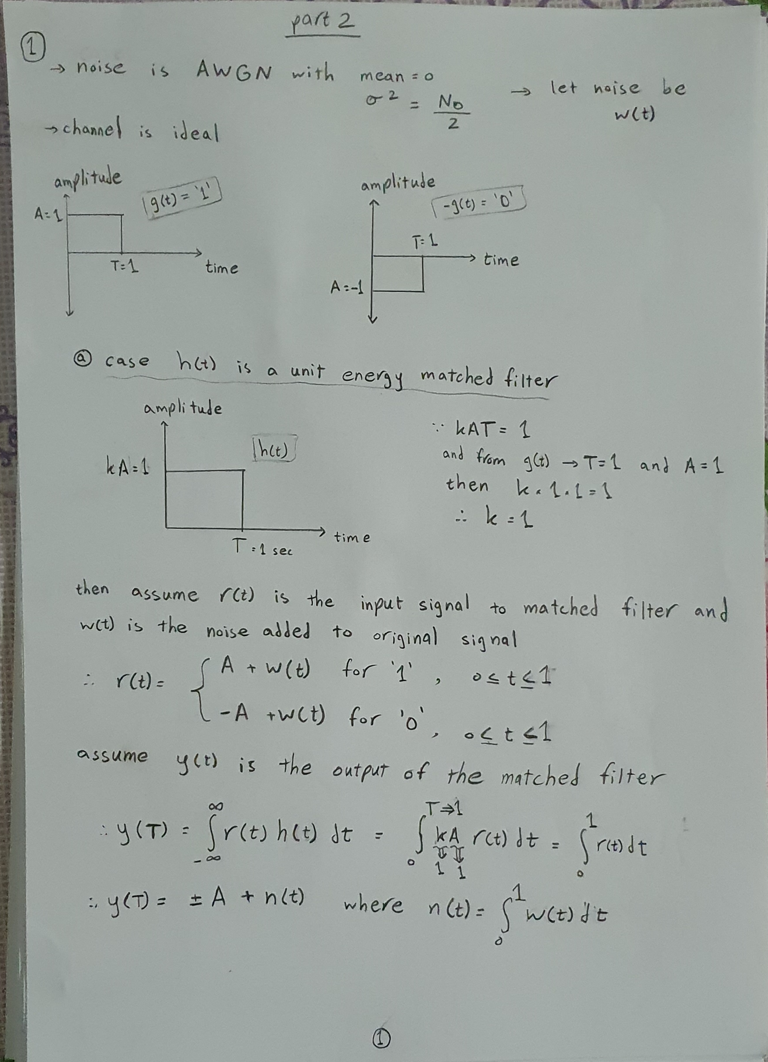**Q)** solution is as follows:

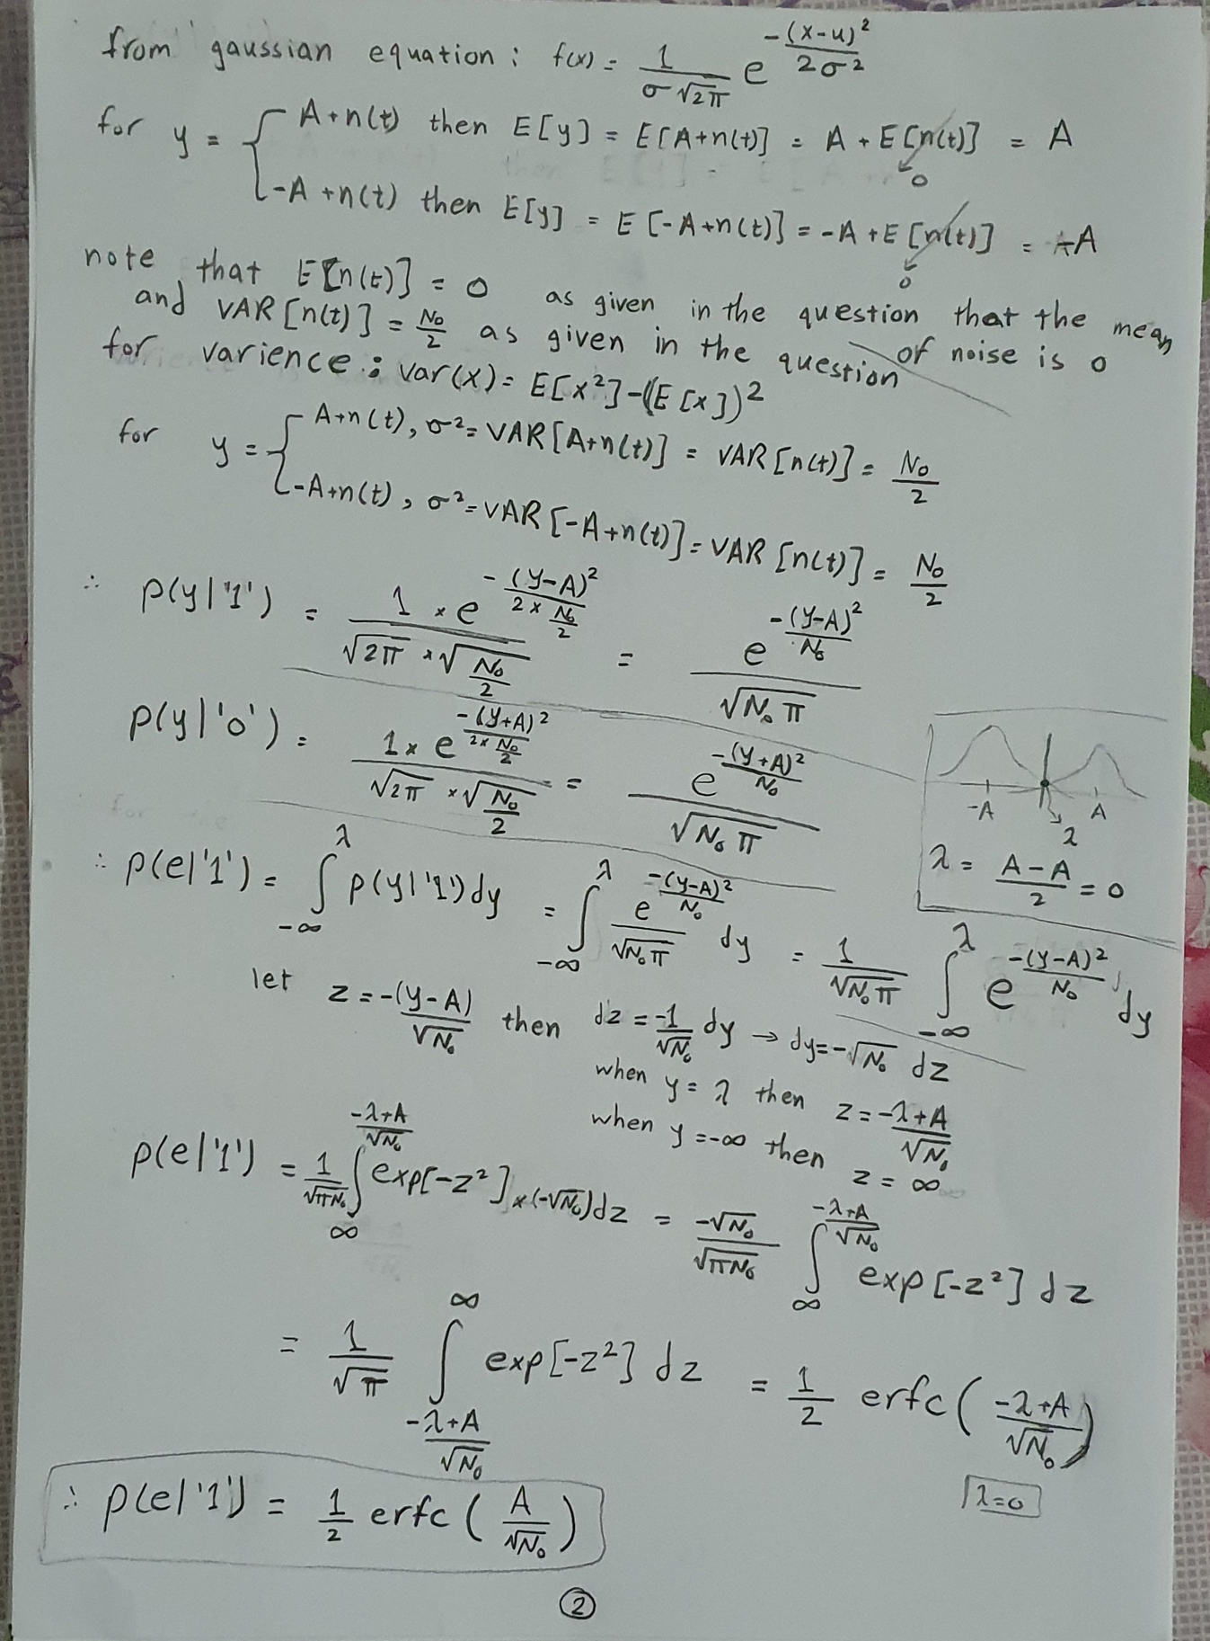

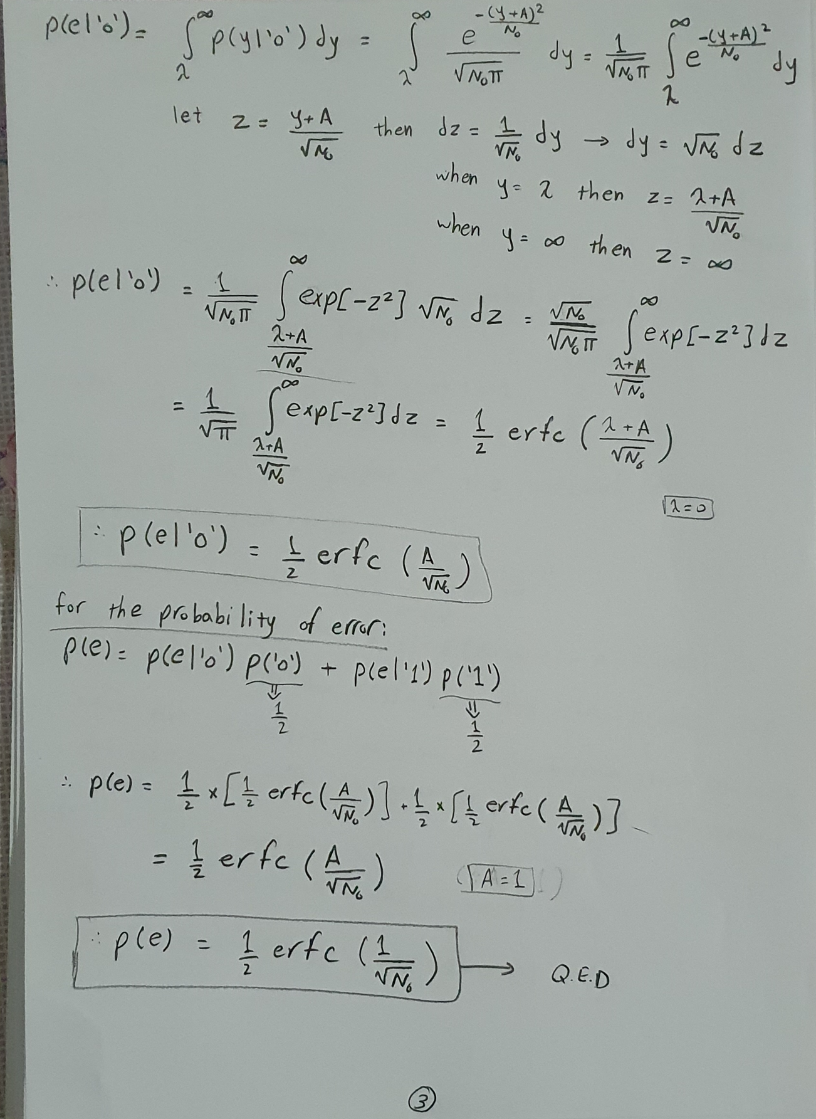

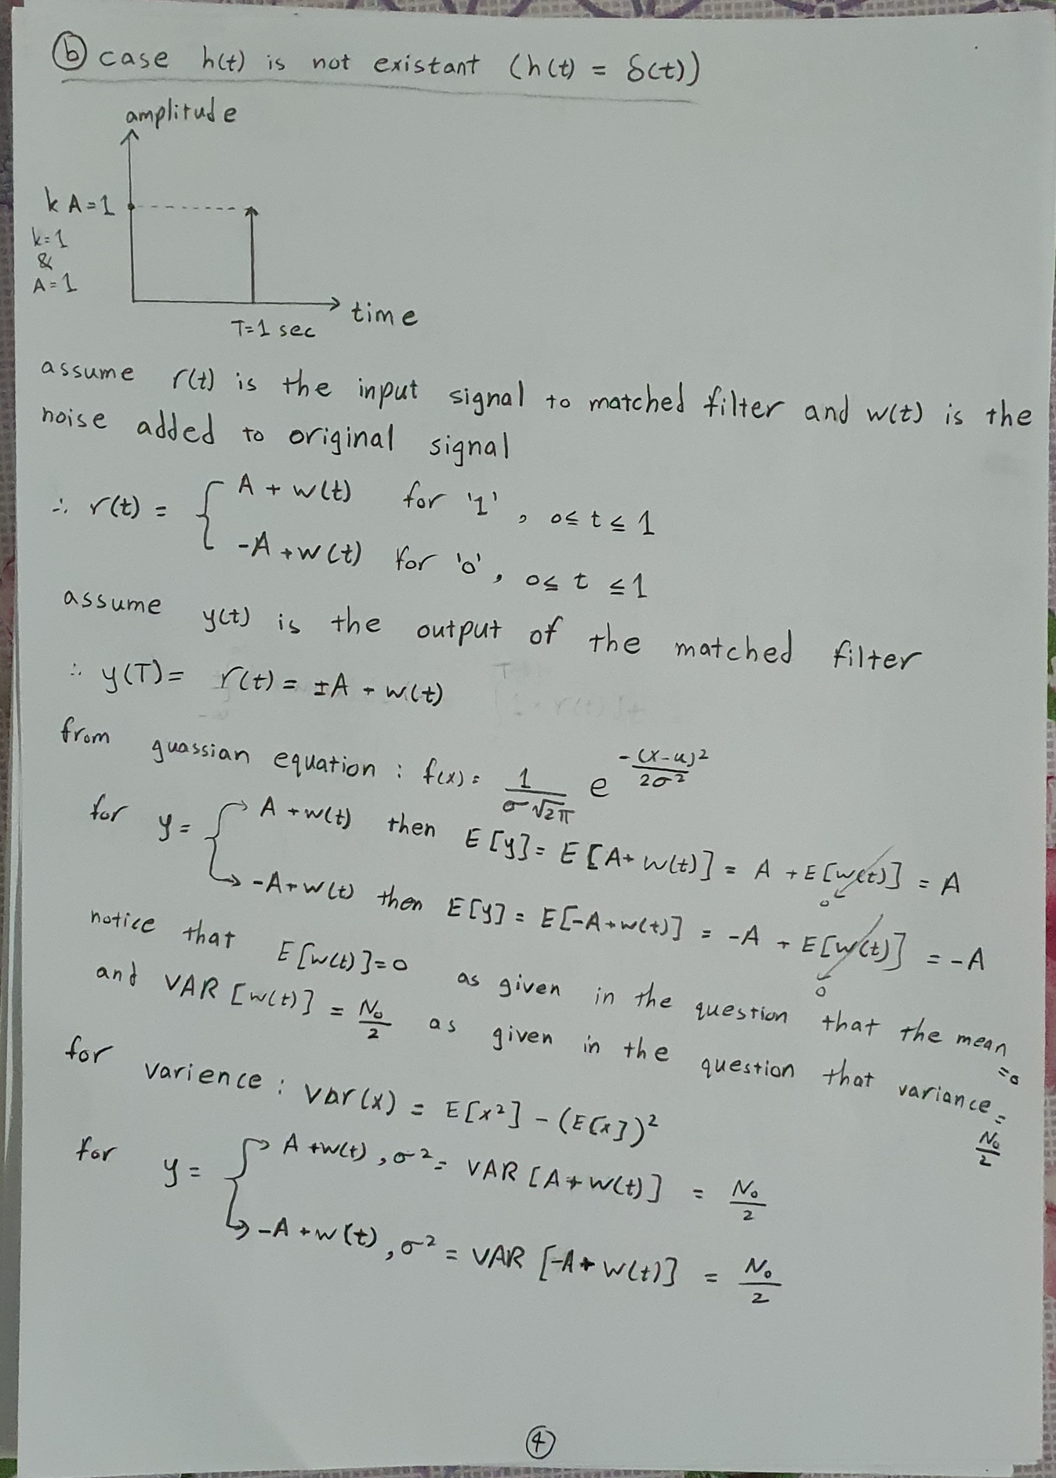

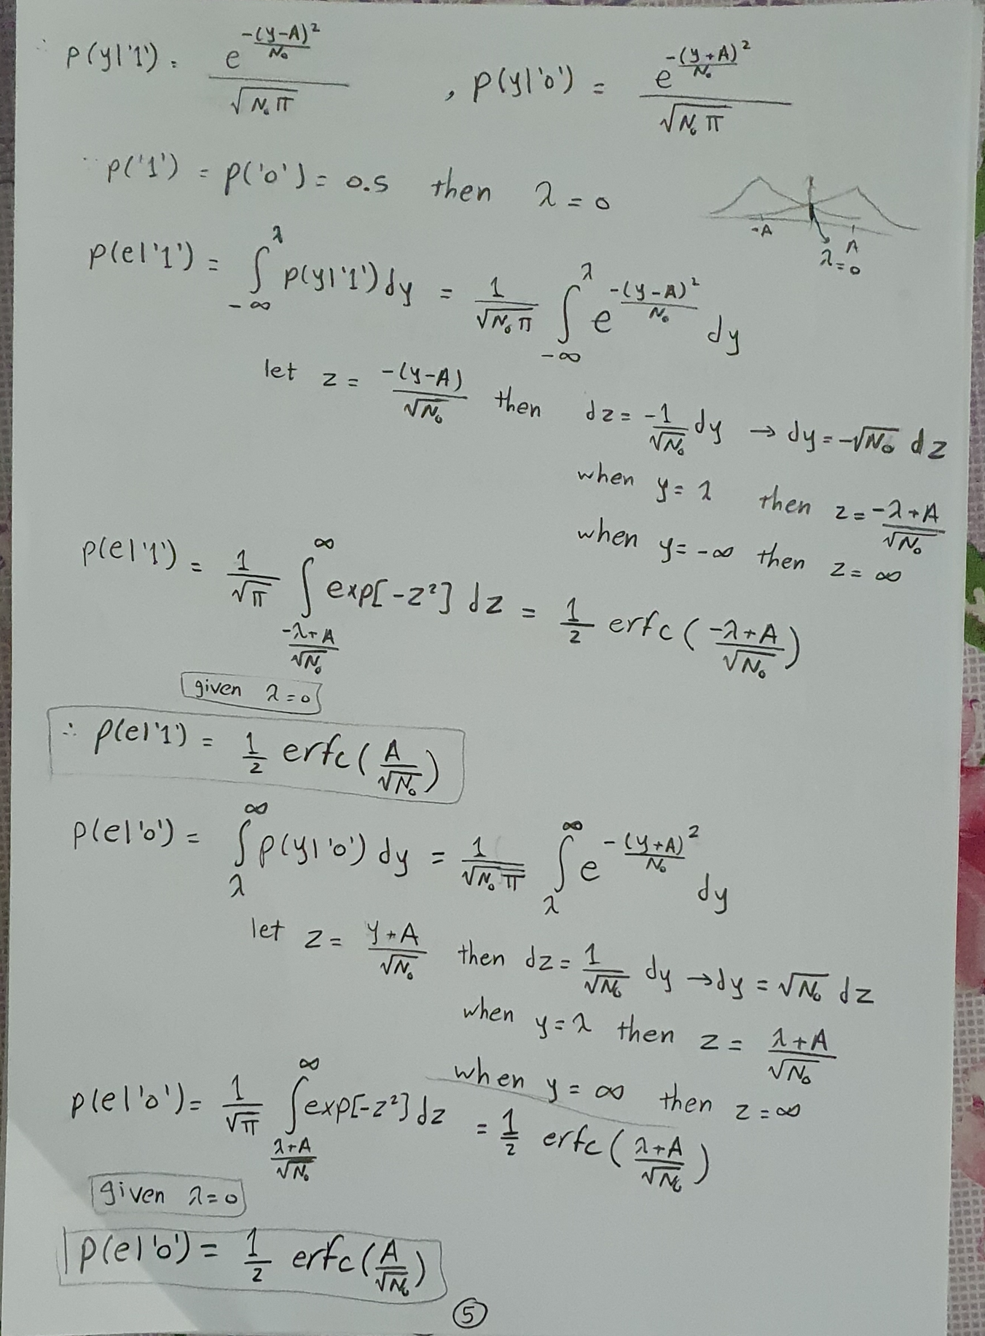

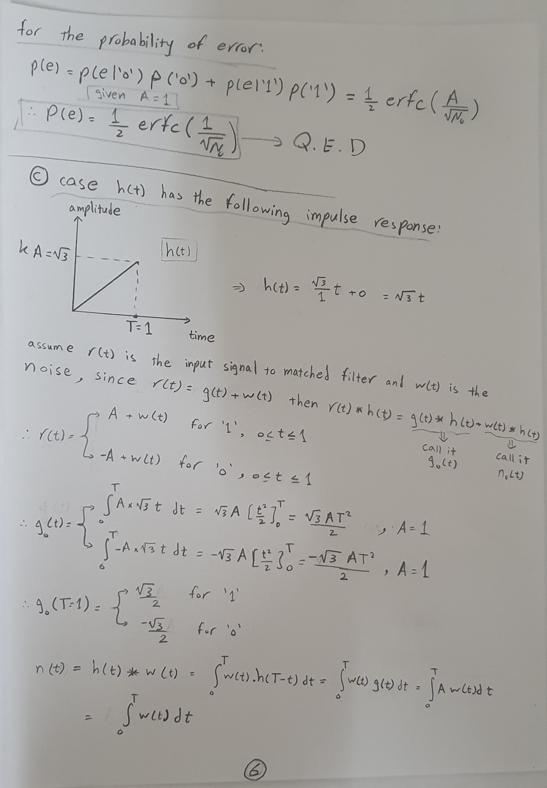

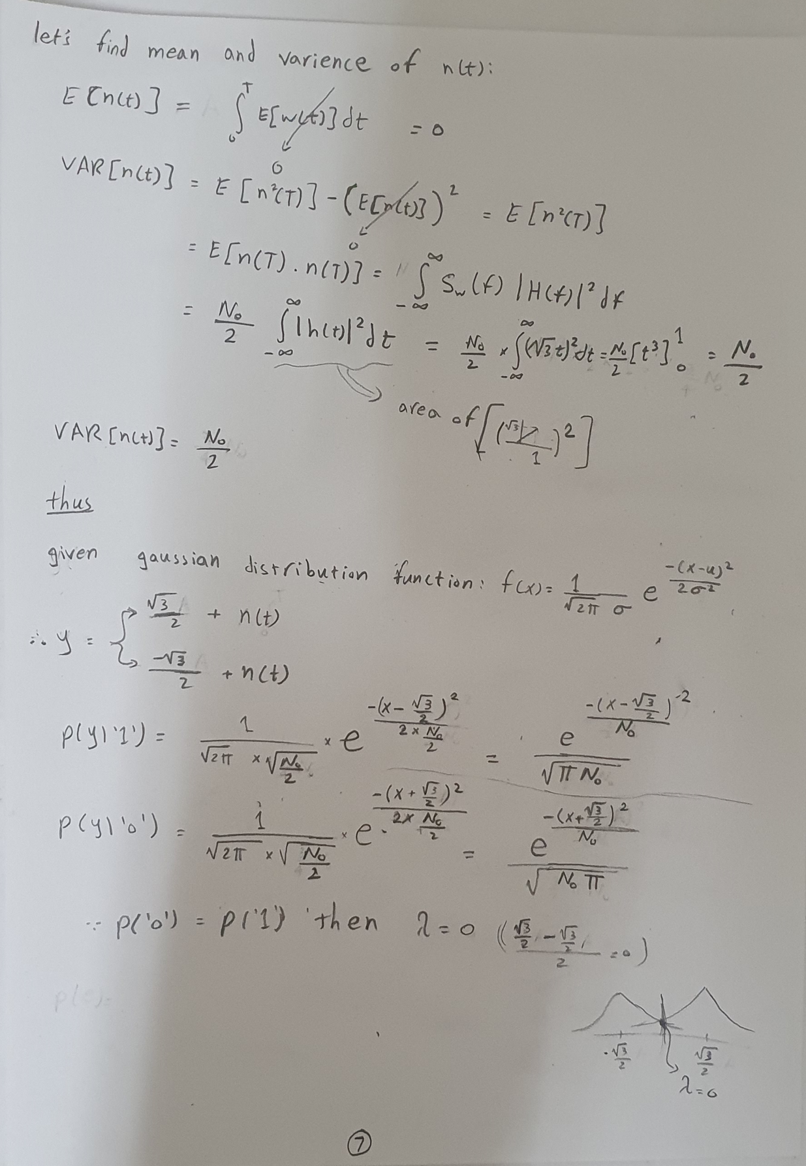

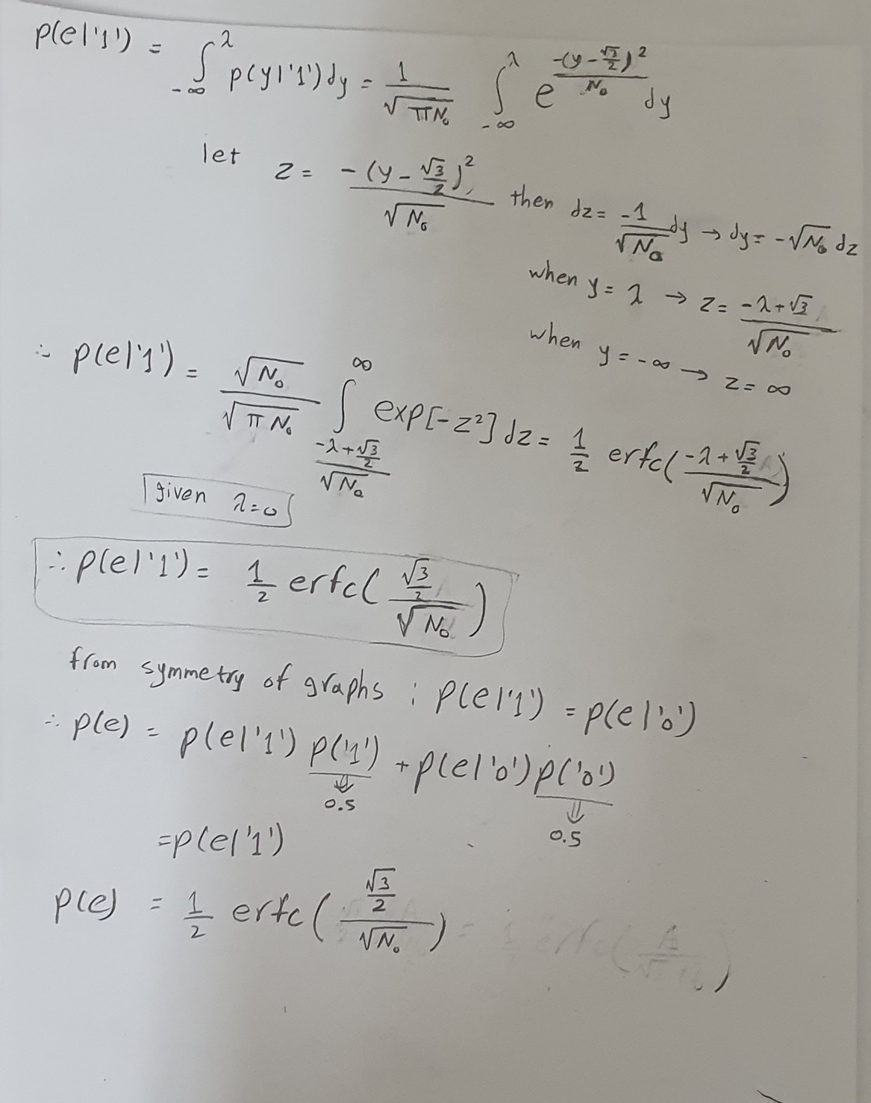

**Simulation of the system**

Suppose we have, a system where number of bits to be sent = 10 bits and for Noise N0 = 2, then this is the output of each stage

**output of the binary source**

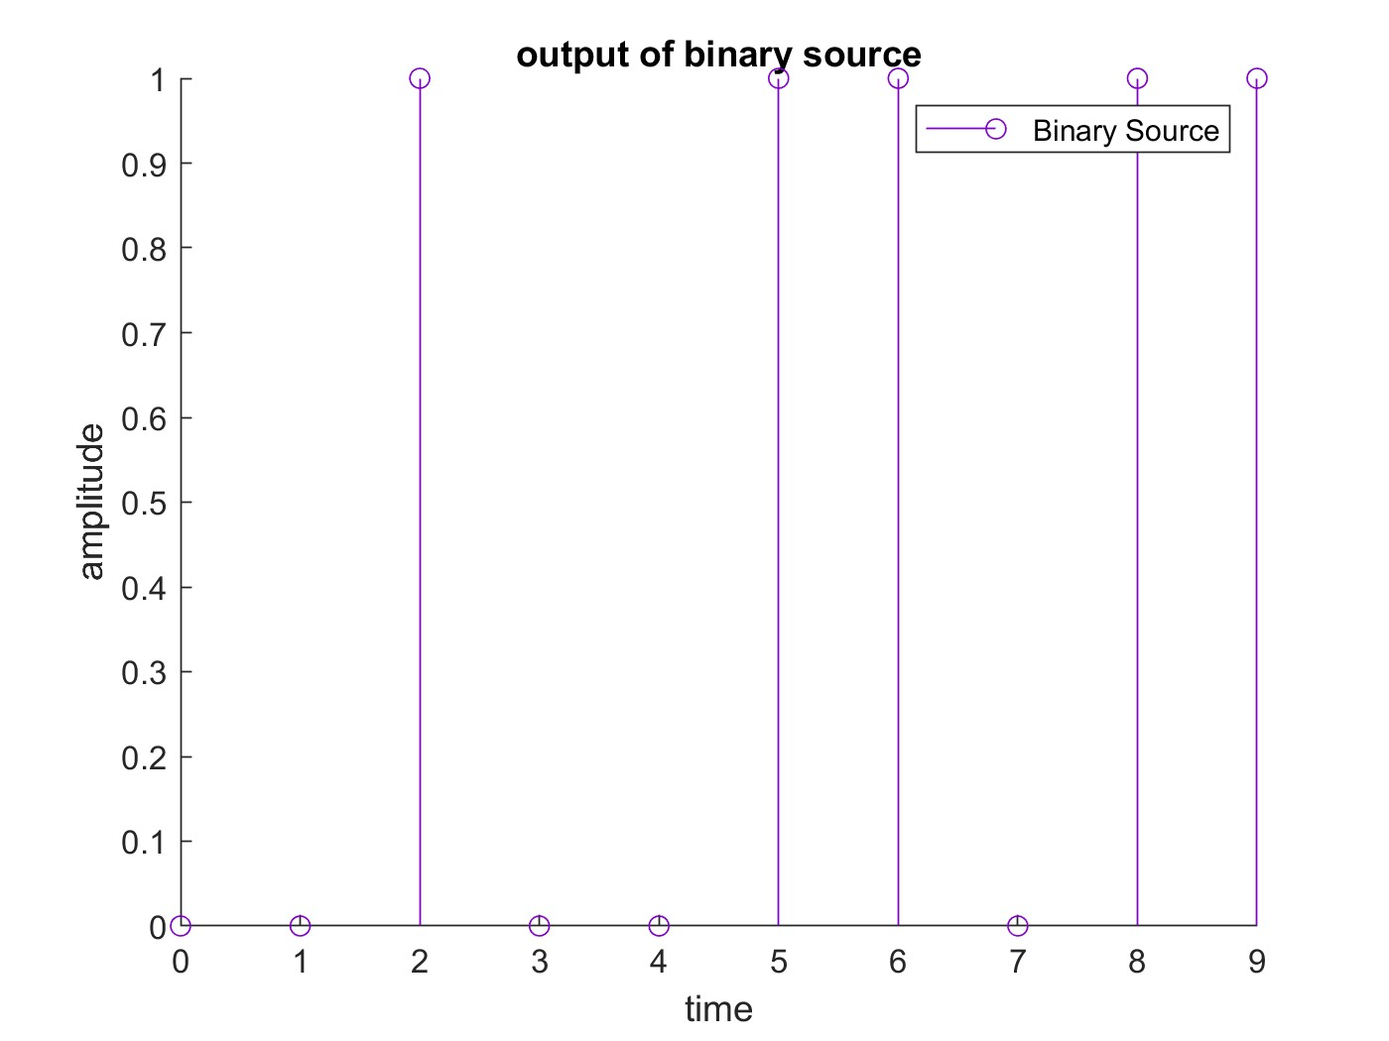

as you see the binary source generated bits to be sent in the following manner: 0010011011

**output of the pulse shape**

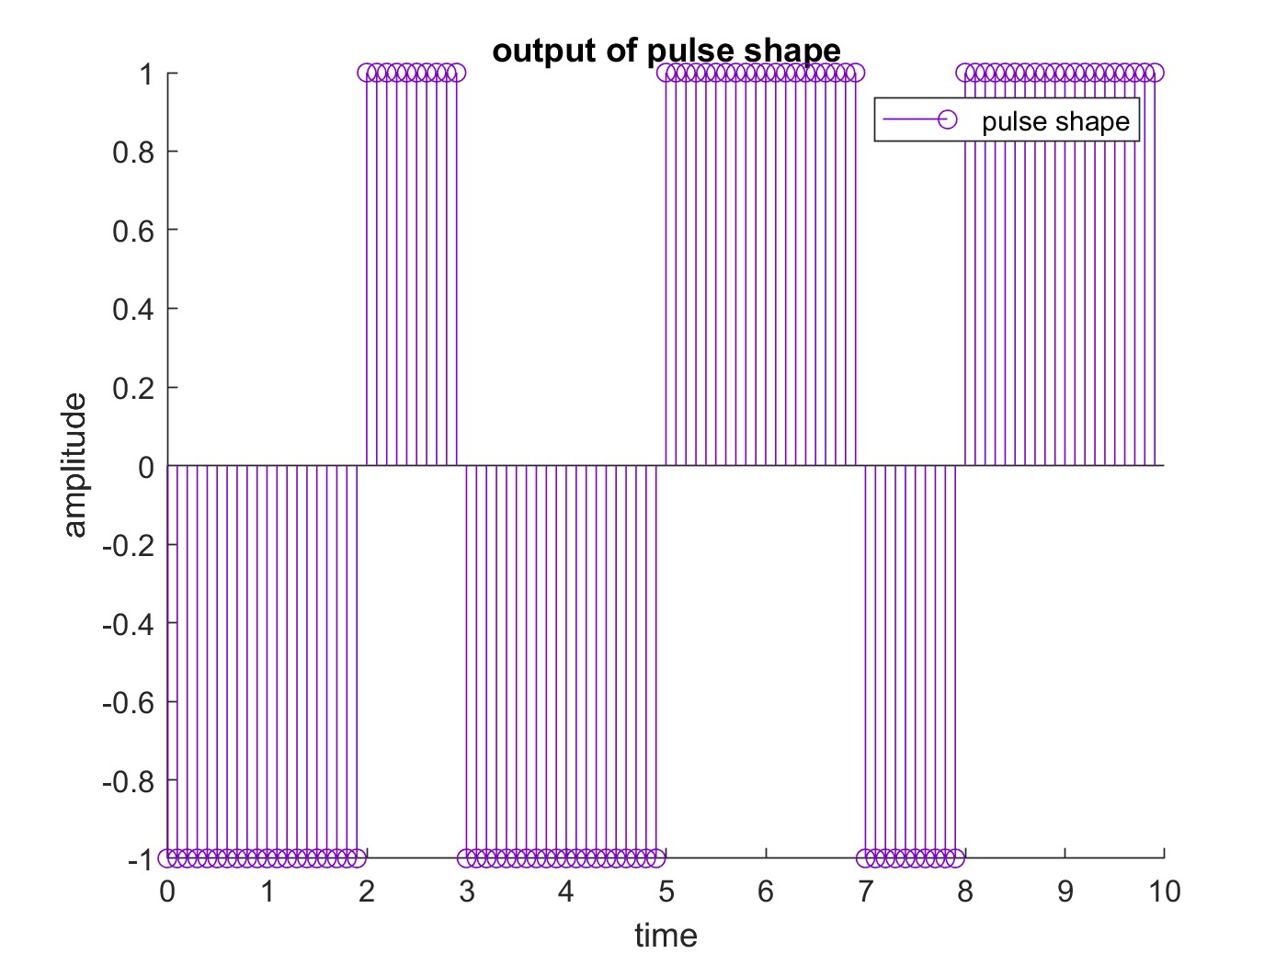

as you see, we repeat each bit 10 times and map 0 to -1 and 1 to 1 so the output of the pulse shape is 100 pulse where each pulse is either 1 or -1

**output of the channel**

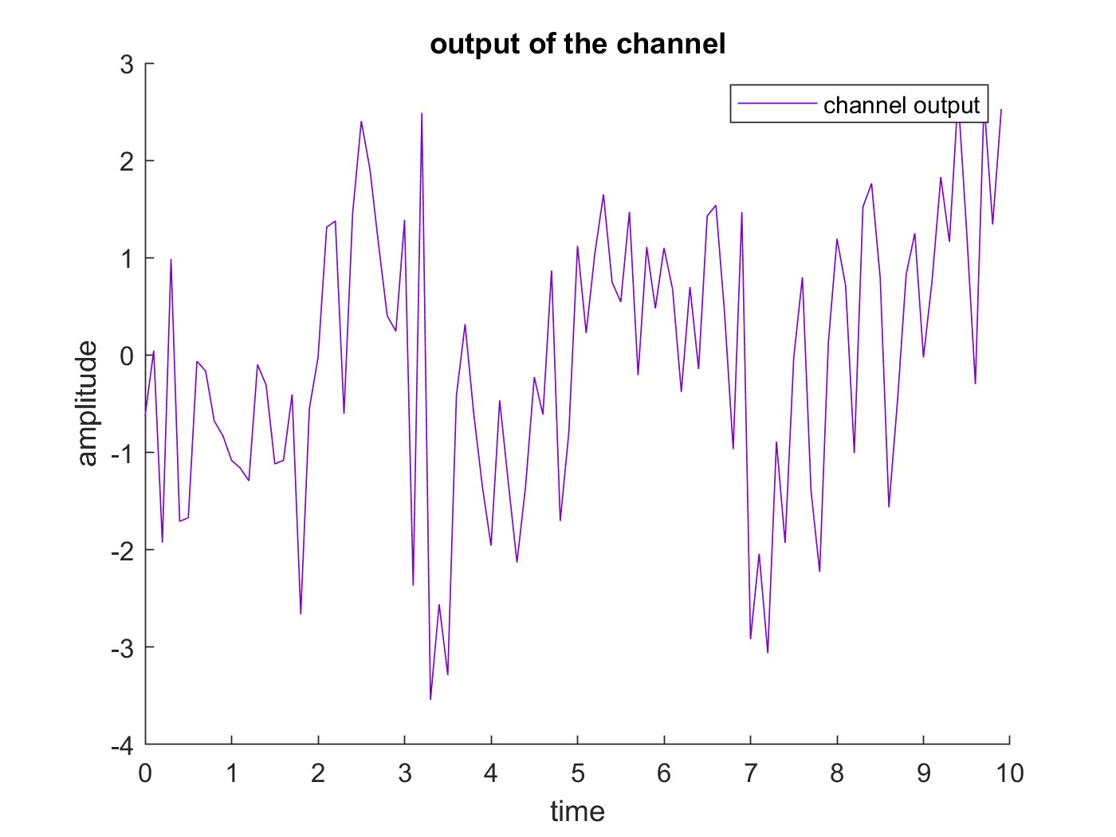

this is how our signal will look like in the channel after adding a noise with mean = 0 and variance = 0.5 (N0 / 2) where the noise follows gaussian distribution.

**output of the receivers**

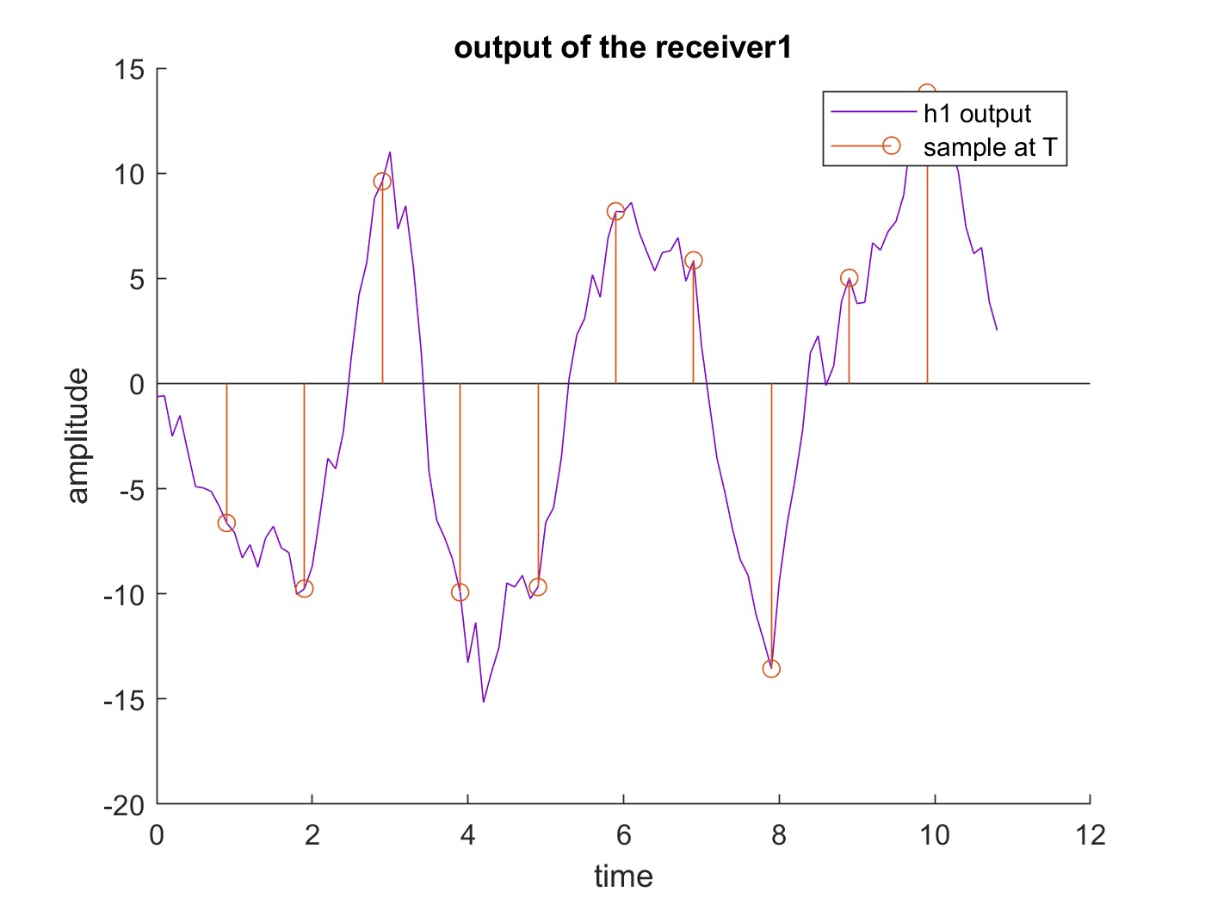

this is the output signal from the matched filter with unit energy (1st case) along with time of sample with period = 1

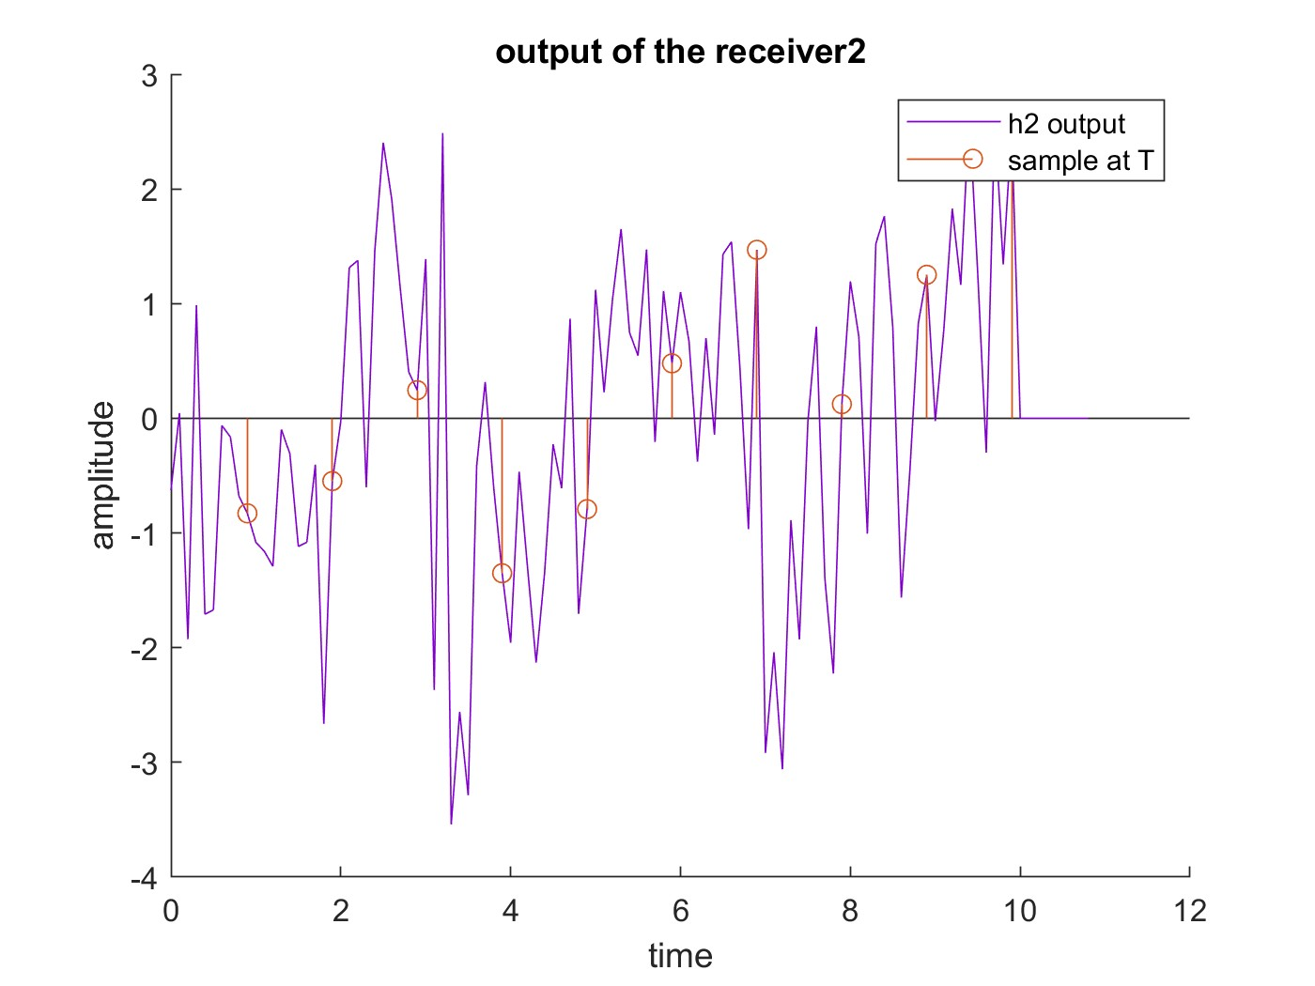

this is the output signal from the receiver when there is no matched filter (2nd case) along with time of sample with period = 1

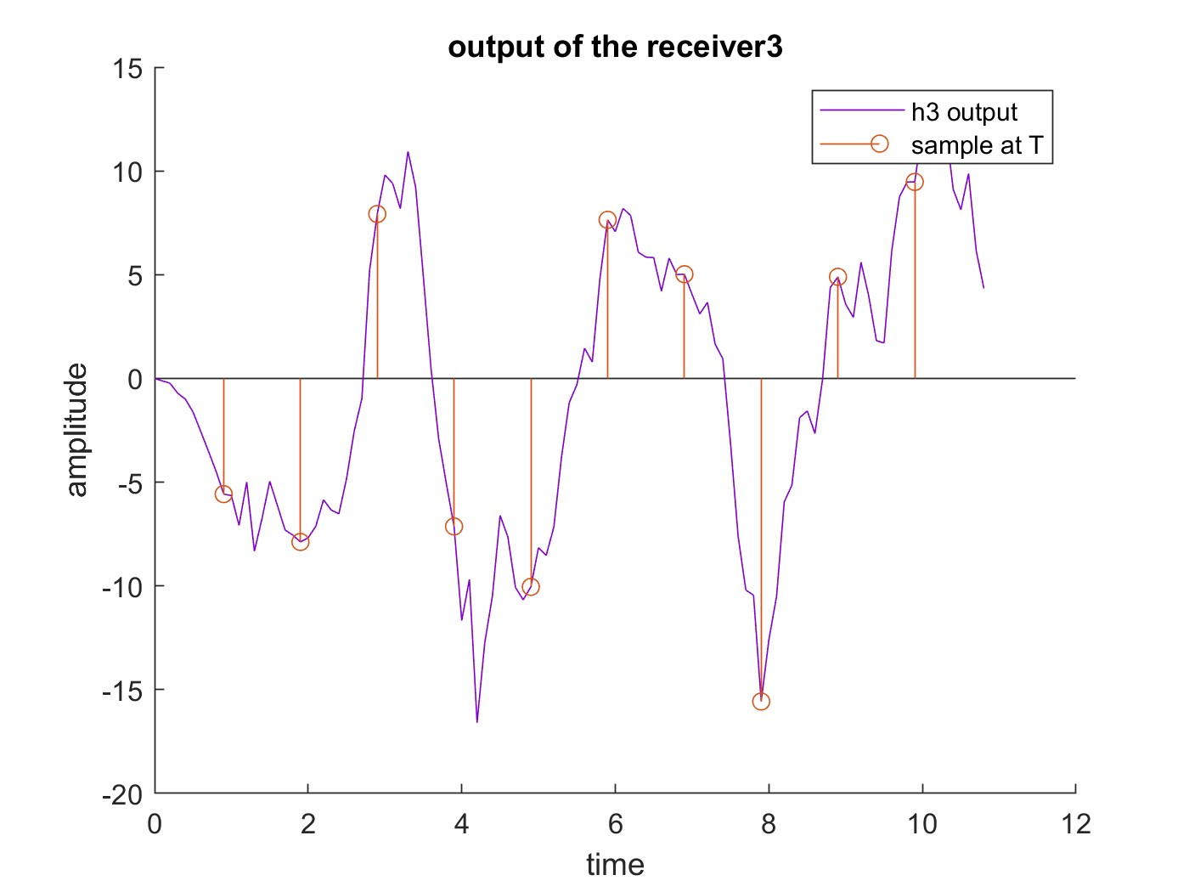

this is the output signal from the receiver when the matched filter has a triangle pulse response with equation $\sqrt{3} t$ (3rd case) along with time of sample with

period = 1

**output of the decoders**

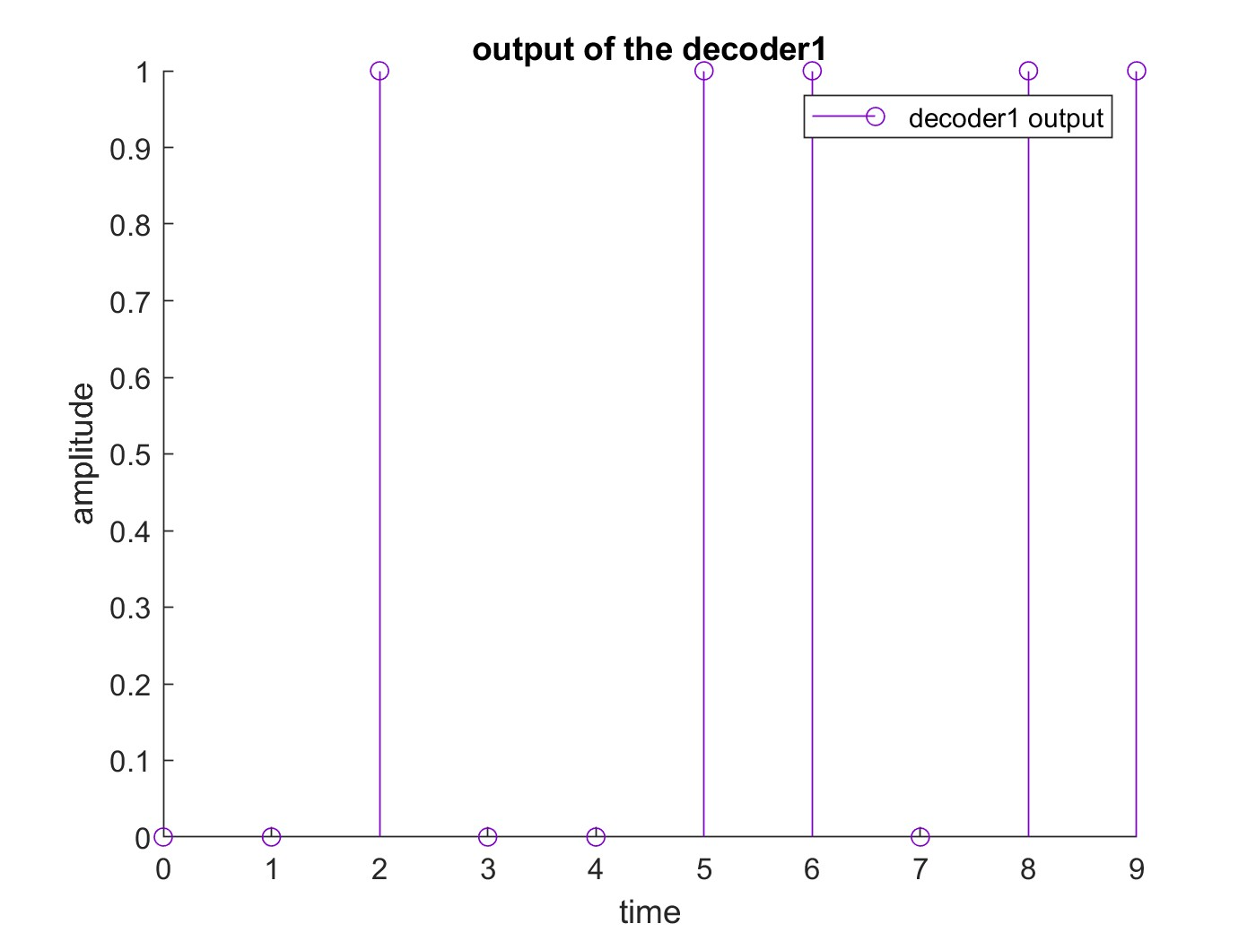

this is the decoded signal when using a matched filter with unit energy (1st case) where the decoded signal is 0010011011 and the original signal was 0010011011 so no error occurred.

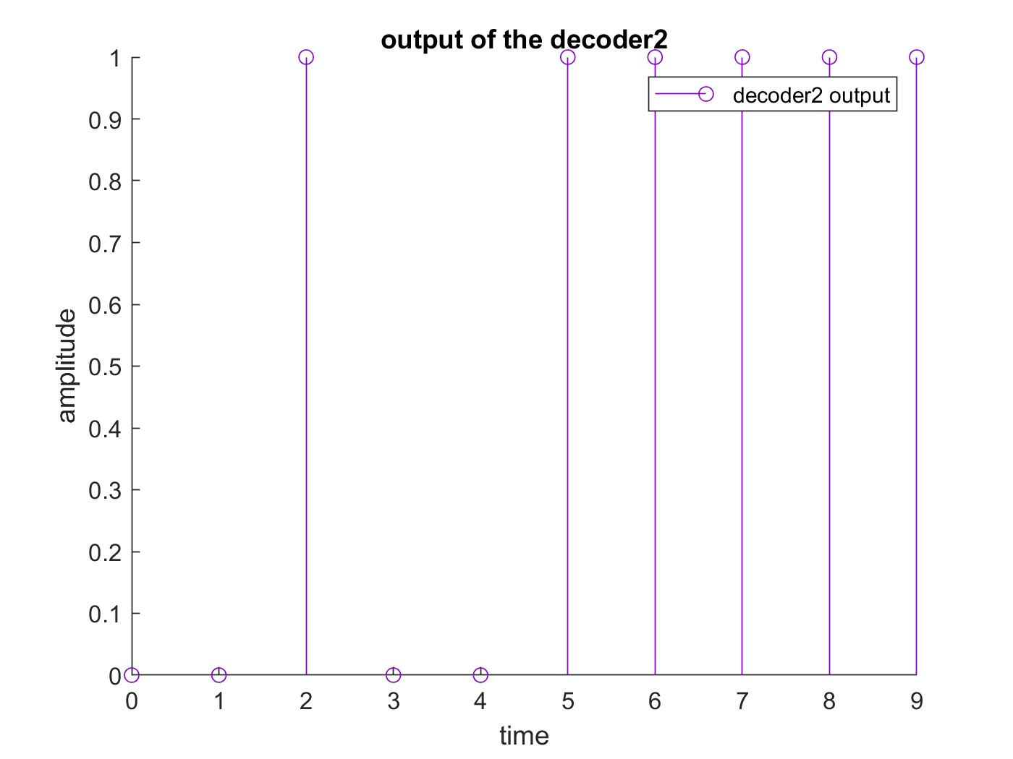

this is the decoded signal when no matched filter was used (2nd case) where the decoded signal is 0010011111 and the original signal was 0010011011 so error occurred at only 1 bit.

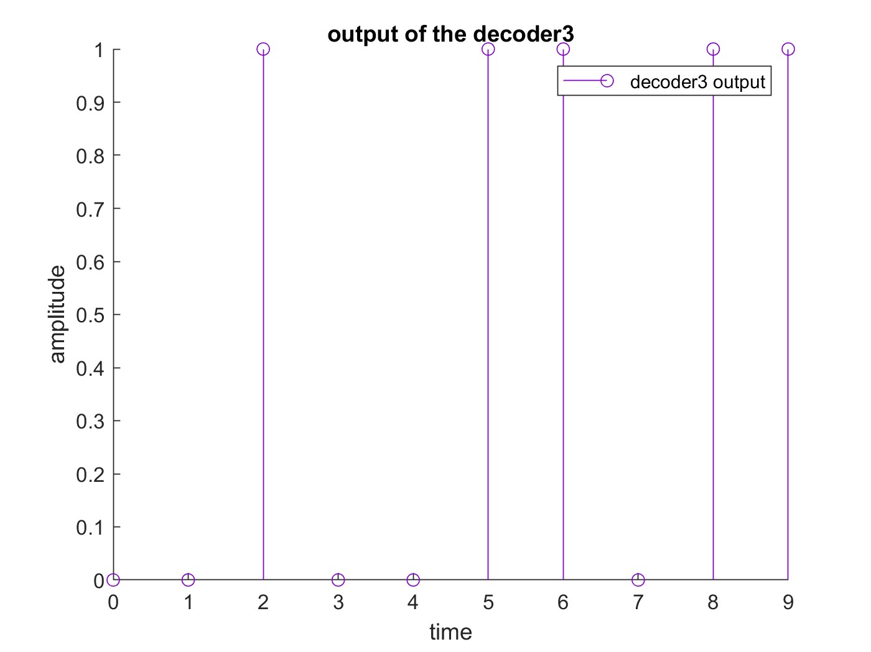

this is the decoded signal when a matched filter with impulse response equation $\sqrt{3} t$ was used (3rd case) where the decoded signal is 0010011011 and the original signal was 0010011011 so no error occurred.

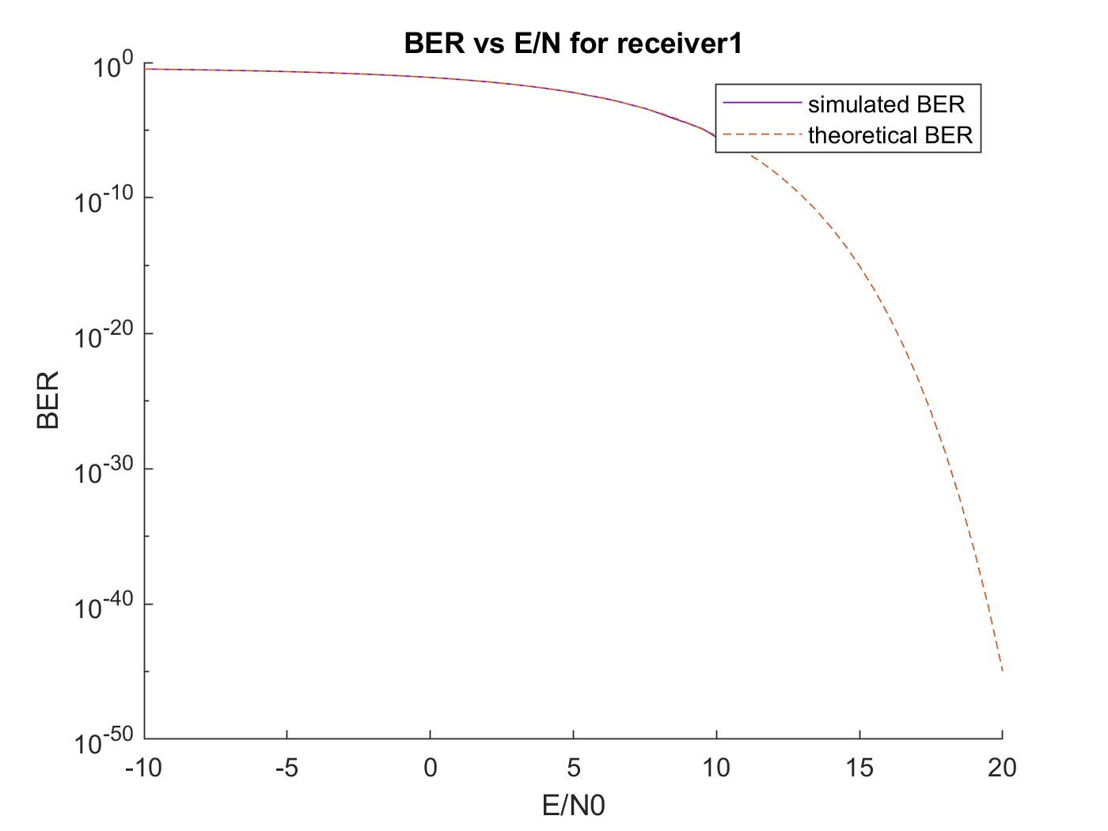**Simulated and theoretical BER vs E/N0**

In case of using a matched filter with unit energy (1st case), the simulated BER is becoming 0 after a specific E/N0 where after that point the signal is received correctly with no problem at all, this is supposed to be the most optimal matched filter where it follows the equation Kg(T-t) and this matched filter impulse response has the same shape as the input signal so it’s supposed to be the most optimal one (Note that in the simulated BER, it discontinues after a specific E/N0 as BER=0 and so log(0) can’t be plot as it tends to -infinity)

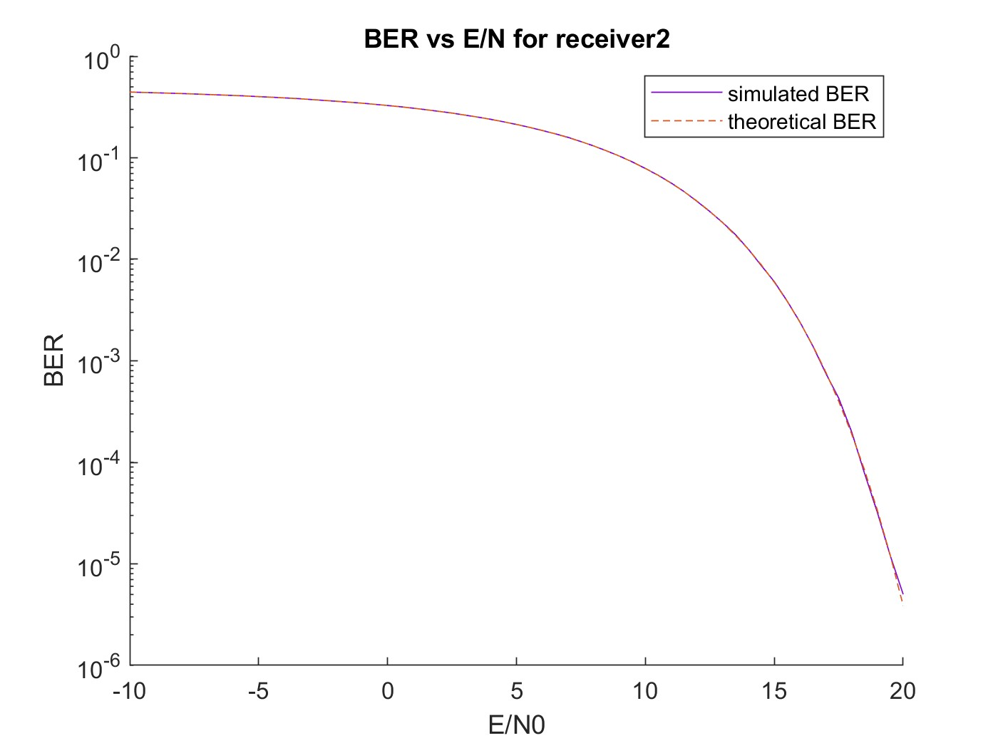in case of not using any matched filter (2nd case), the simulated BER is nearly equal the theoretical BER as it appears on the graph and it’s the worst BER as there is no matched filter (Note that in the simulated BER, it discontinues after a specific E/N0 as BER=0 and so log(0) can’t be plot as it tends to -infinity)

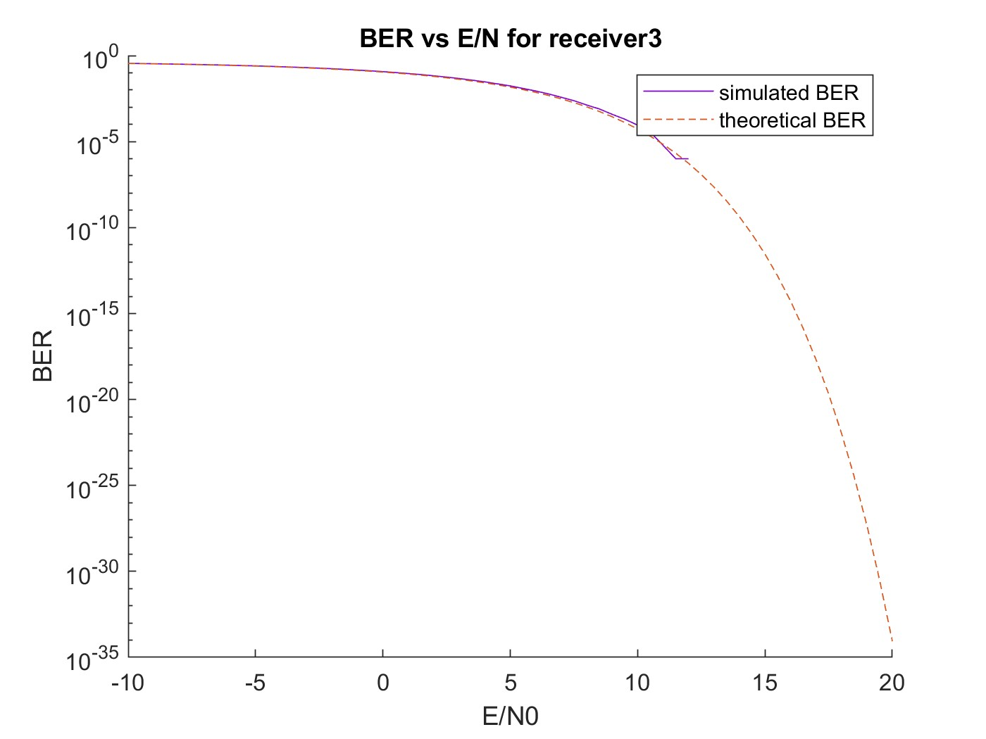in case of using a matched filter with impulse response equation $\sqrt{3} t$ (3rd case) , the BER is better than not using matched but worse than the optimal filter used in 1st case,

**Q5)** the BER is a decreasing function in E/N0 as E/N0 represents energy of the original signal to that of the noise as the ratio increases it means that the energy of the original signal is more dominant and can be received successfully as the rate of error of receiving bits (BER) will decrease.

**Q6)** the case which have the lowest BER is the 1st case as the impulse response of the matched filter is the optimal filter following the equation KS(T-t) with K =1 as the impulse response shape of the matched filter is same shape as the input signal S(t) so it’s the most optimal filter with the lowest BER.

**Total Code**

|  |
| --- |
| % ------------------------------  % needed variables  % ------------------------------  % this variable is used to switch between plotting the output of each stage  % given N0 = 2 and plotting BER vs E/N0 for different values of N0  displayBlocksOutput = false;  % this variable is used to define the number of bits to be generated  numOfBits = 10000;  % energy of one symbol = 1  E = 1;  % generate different values for N0 where E/N0 ranges from -10db to 20db  E_over_N0 = -10:0.5:20; % values in db  N0_arr = E_over_N0 ./ 10;  % select the values of N0 whether it's for plotting blocks output signals  % or plotting BER vs E/N0 for different values of N0  if displayBlocksOutput == true  N0_arr = 2;  numOfBits = 10;  else  N0_arr = E ./ (10 .^ N0_arr); % getting the actual value of N0  end  simulatedProbabilityOfError1 = zeros(1, length(E_over_N0)); % simulated pobability of error case 1  simulatedProbabilityOfError2 = zeros(1, length(E_over_N0)); % simulated pobability of error case 2  simulatedProbabilityOfError3 = zeros(1, length(E_over_N0)); % simulated pobability of error case 3  % importat note: in the attached paper I proved that theoriticalProbabilityOfError2  % for receiver 2 is equal to 0.5*erfc(1/sqrt(N0)) but the problem in my  % prove is that I made the area of the impulse signal to be 1, so I  % made a width of the impulse to be 1/10 of the rectangle so the area  % of the impulse is 1/10, so after plugining it in the equations, the  % theoriticalProbabilityOfError2 = 0.5*erfc(1/sqrt(N0*10))  % calculate the theoretical probability of error  theoriticalProbabilityOfError1(i) = 0.5*erfc(1/sqrt(N0));  theoriticalProbabilityOfError2(i) = 0.5*erfc(1/sqrt(N0*10));  theoriticalProbabilityOfError3(i) = 0.5*erfc(sqrt(3)/(2*sqrt(N0)));  % ------------------------------  % BLOCK1 : Binary Source  % ------------------------------  % this is the array that holds our generated pulse  BinarySource = randi([0, 1], 1, numOfBits);  % ------------------------------  % BLOCK2 : pulse shape  % ------------------------------  pulseShapedSignal = pulseShape(BinarySource, 10);  % ------------------------------  % BLOCK3 : channel  % ------------------------------  for i = 1:length(N0_arr)  % get the current N0  N0 = N0_arr(i);  % get the result signal after adding the noise  R_t = channel(pulseShapedSignal, N0);    % ------------------------------  % BLOCK4 : Receive filter  % ------------------------------    % h(t) in case of unit energy filter (case 1)  h1_t = ones(1, 10);  convolutedSgn1 = receiveFilter(h1_t, R_t);    % h(t) in case of matched filter doesn't exit (case 2)  h2_t = [];  convolutedSgn2 = receiveFilter(h2_t, R_t);      % h(t) in case of triangular respose (case 3)  T = 0:0.11:1;  h3_t = sqrt(3) .* T;  convolutedSgn3 = receiveFilter(h3_t, R_t);    % ------------------------------  % BLOCK5 : sample at T  % ------------------------------    % this is in case 1 for our matched filter  sampledData1 = sampler(convolutedSgn1, 10);      % this is in case 2 for our matched filter  sampledData2 = sampler(convolutedSgn2, 10);      % this is in case 3 for our matched filter  sampledData3 = sampler(convolutedSgn3, 10);      % ------------------------------  % BLOCK6 : decode to 0 and 1  % ------------------------------      % this is in case 1 for our matched filter  decodedVals1 = decode(sampledData1);    % this is in case 2 for our matched filter  decodedVals2 = decode(sampledData2);    % this is in case 3 for our matched filter  decodedVals3 = decode(sampledData3);  % ------------------------------  % collecting data  % ------------------------------  % calculate the simulated probability of error  simulatedProbabilityOfError1(i) = sum(decodedVals1 ~= BinarySource) / numOfBits;  simulatedProbabilityOfError2(i) = sum(decodedVals2 ~= BinarySource) / numOfBits;  simulatedProbabilityOfError3(i) = sum(decodedVals3 ~= BinarySource) / numOfBits;    % calculate the theoretical probability of error  theoriticalProbabilityOfError1(i) = 0.5*erfc(1/sqrt(N0));  theoriticalProbabilityOfError2(i) = 0.5*erfc(1/sqrt(N0));  theoriticalProbabilityOfError3(i) = 0.5*erfc(sqrt(3)/(2*sqrt(N0)));  if displayBlocksOutput == true  % plot the ouput from each stage    % plotting the output of binary source  T = 0:1:numOfBits-1; % constructing the time signal  figure  title('output of binary source');  hold on  xlabel('time');  ylabel('amplitude');  h = stem(T, BinarySource, 'DisplayName', 'Binary Source');  h.Color = [0.5 0 0.8];  legend  hold off  % plotting the output of pulse shape  T = 0:0.1:(numOfBits-0.1); % constructing the time signal  figure  title('output of pulse shape');  hold on  xlabel('time');  ylabel('amplitude');  h = stem(T, pulseShapedSignal, 'DisplayName', 'pulse shape');  h.Color = [0.5 0 0.8];  legend  hold off  % plotting the output of channel  T = 0:0.1:(numOfBits-0.1); % constructing the time signal  figure  title('output of the channel');  hold on  xlabel('time');  ylabel('amplitude');  h = plot(T, R_t, 'DisplayName', 'channel output');  h.Color = [0.5 0 0.8];  legend  hold off  % plotting the output of receive filter along with sampling  T = 0:0.1:(numOfBits+0.8); % constructing the time signal  indexes = NaN(1, numOfBits*11 - 1);  for i = 10:10:(numOfBits*11 - 1)  indexes(i) = 1;  end  % case 1  figure  title('output of the receiver1');  hold on  xlabel('time');  ylabel('amplitude');  h = plot(T, convolutedSgn1, 'DisplayName', 'h1 output');  h.Color = [0.5 0 0.8];  % plotting sampling time  sampleFunc = indexes .* convolutedSgn1;  stem(T, sampleFunc, 'DisplayName', 'sample at T' );  legend  hold off    % case 2  figure  title('output of the receiver2');  hold on  xlabel('time');  ylabel('amplitude');  h = plot(T, convolutedSgn2, 'DisplayName', 'h2 output');  h.Color = [0.5 0 0.8];  % plotting sampling time  sampleFunc = indexes .* convolutedSgn2;  stem(T, sampleFunc, 'DisplayName', 'sample at T' );  legend  hold off  % case 3  figure  title('output of the receiver3');  hold on  xlabel('time');  ylabel('amplitude');  h = plot(T, convolutedSgn3, 'DisplayName', 'h3 output');  h.Color = [0.5 0 0.8];  % plotting sampling time  sampleFunc = indexes .* convolutedSgn3;  stem(T, sampleFunc, 'DisplayName', 'sample at T' );  legend  hold off  % plotting the output of decoders  T = 0:1:numOfBits-1; % constructing the time signal  % case 1  figure  title('output of the decoder1');  hold on  xlabel('time');  ylabel('amplitude');  h = stem(T, decodedVals1, 'DisplayName', 'decoder1 output');  h.Color = [0.5 0 0.8];  legend  hold off  % case 2  figure  title('output of the decoder2');  hold on  xlabel('time');  ylabel('amplitude');  h = stem(T, decodedVals2, 'DisplayName', 'decoder2 output');  h.Color = [0.5 0 0.8];  legend  hold off  % case 3  figure  title('output of the decoder3');  hold on  xlabel('time');  ylabel('amplitude');  h = stem(T, decodedVals3, 'DisplayName', 'decoder3 output');  h.Color = [0.5 0 0.8];  legend  hold off    end    end  % ------------------------------  % plotting BER vs E/N0 for different values of N0  % ------------------------------  if displayBlocksOutput == false    % plotting the theoretical and simulated Bit Error Rate (BER) Vs  % E/No for receiver 1  figure  title('BER vs E/N for receiver1');  hold on  xlabel('E/N0');  ylabel('BER');  set(gca, 'YScale', 'log')  h = plot(E_over_N0, simulatedProbabilityOfError1, 'DisplayName', 'simulated BER');  h.Color = [0.5 0 0.8];  plot(E_over_N0, theoriticalProbabilityOfError1, '--', 'DisplayName', 'theoretical BER');  legend  hold off  % plotting the theoretical and simulated Bit Error Rate (BER) Vs  % E/No for receiver 2  figure  title('BER vs E/N for receiver2');  hold on  xlabel('E/N0');  ylabel('BER');  set(gca, 'YScale', 'log')  h = plot(E_over_N0, simulatedProbabilityOfError2, 'DisplayName', 'simulated BER');  h.Color = [0.5 0 0.8];  plot(E_over_N0, theoriticalProbabilityOfError2, '--', 'DisplayName', 'theoretical BER');  legend  hold off  % plotting the theoretical and simulated Bit Error Rate (BER) Vs  % E/No for receiver 3  figure  title('BER vs E/N for receiver3');  hold on  xlabel('E/N0');  ylabel('BER');  set(gca, 'YScale', 'log')  h = plot(E_over_N0, simulatedProbabilityOfError3, 'DisplayName', 'simulated BER');  h.Color = [0.5 0 0.8];  plot(E_over_N0, theoriticalProbabilityOfError3, '--', 'DisplayName', 'theoretical BER');  legend  hold off  end  % this function is to convert pulses to (+ and -) rectangle pulses (pulse  % shape blocl)  function [G_t] = pulseShape(binaryBitsArr, numOfPulsesPerOnePulse)    % needed varaibles for our for loop  T = 0:1:numOfPulsesPerOnePulse-1;  T = T / numOfPulsesPerOnePulse;  V = [];  % repeat each pulse 10 times to make a rectangle shape pulse  for bit = binaryBitsArr  % convert each signal to +1 and -1 insteal of 0 and 1  if bit == 0  V = cat(2, V, -rectpuls(T, numOfPulsesPerOnePulse));  else  V = cat(2, V, rectpuls(T, numOfPulsesPerOnePulse));  end  end  % return the result  G_t = V;  end  % this function is to add noise to the channel (N0)  function [R_t] = channel(originalSignal, N0)    % generate the noise from gaussian distribution given mean = 0 and  % varience = N0 / 2, refer to https://ch.mathworks.com/help/matlab/math/random-numbers-with-specific-mean-and-variance.html  noise = sqrt(N0 / 2) .* randn([1, length(originalSignal)]);  % add the noise to the original signal (sqrt(10) is to normalized the length of the one signal pulse)  R_t = originalSignal/sqrt(10) + noise;  end  % this function is used to convolute the matched filter with the signal  % output from the channel  function [convolutedSgn] = receiveFilter(H_t, R_t)  if(isempty(H_t))  % the matched filter doesn't exist  convolutedSgn = cat(2, R_t, zeros(1, 9));  else  % convulte the signal output from the channel with matched filter  % response  convolutedSgn = conv(H_t, R_t);  end  end  % this function is used to sample at time T ( sample every N values)  function [sampledData] = sampler(data, N)    % temporary vector  tempVec = zeros(1, floor(length(data)/N));  % sample every N times  for i = 10:N:length(data)  tempVec(i/10) = data(i);  end    % return the result  sampledData = tempVec;  end  % this function is used to decode the results to either 0 or 1  function [decodedVals] = decode(data)  % create temporary vector  tempVec = data;  % map the values to either 1 or 0  tempVec(tempVec <= 0) = 0;  tempVec(tempVec > 0) = 1;  % return the result  decodedVals = tempVec;  end |